**Agile Process and Method**

The Agile Method is a particular approach to project management that is utilized in software development. This method assists teams in responding to the unpredictability of constructing software. It uses incremental, iterative work sequences that are commonly known as sprints.

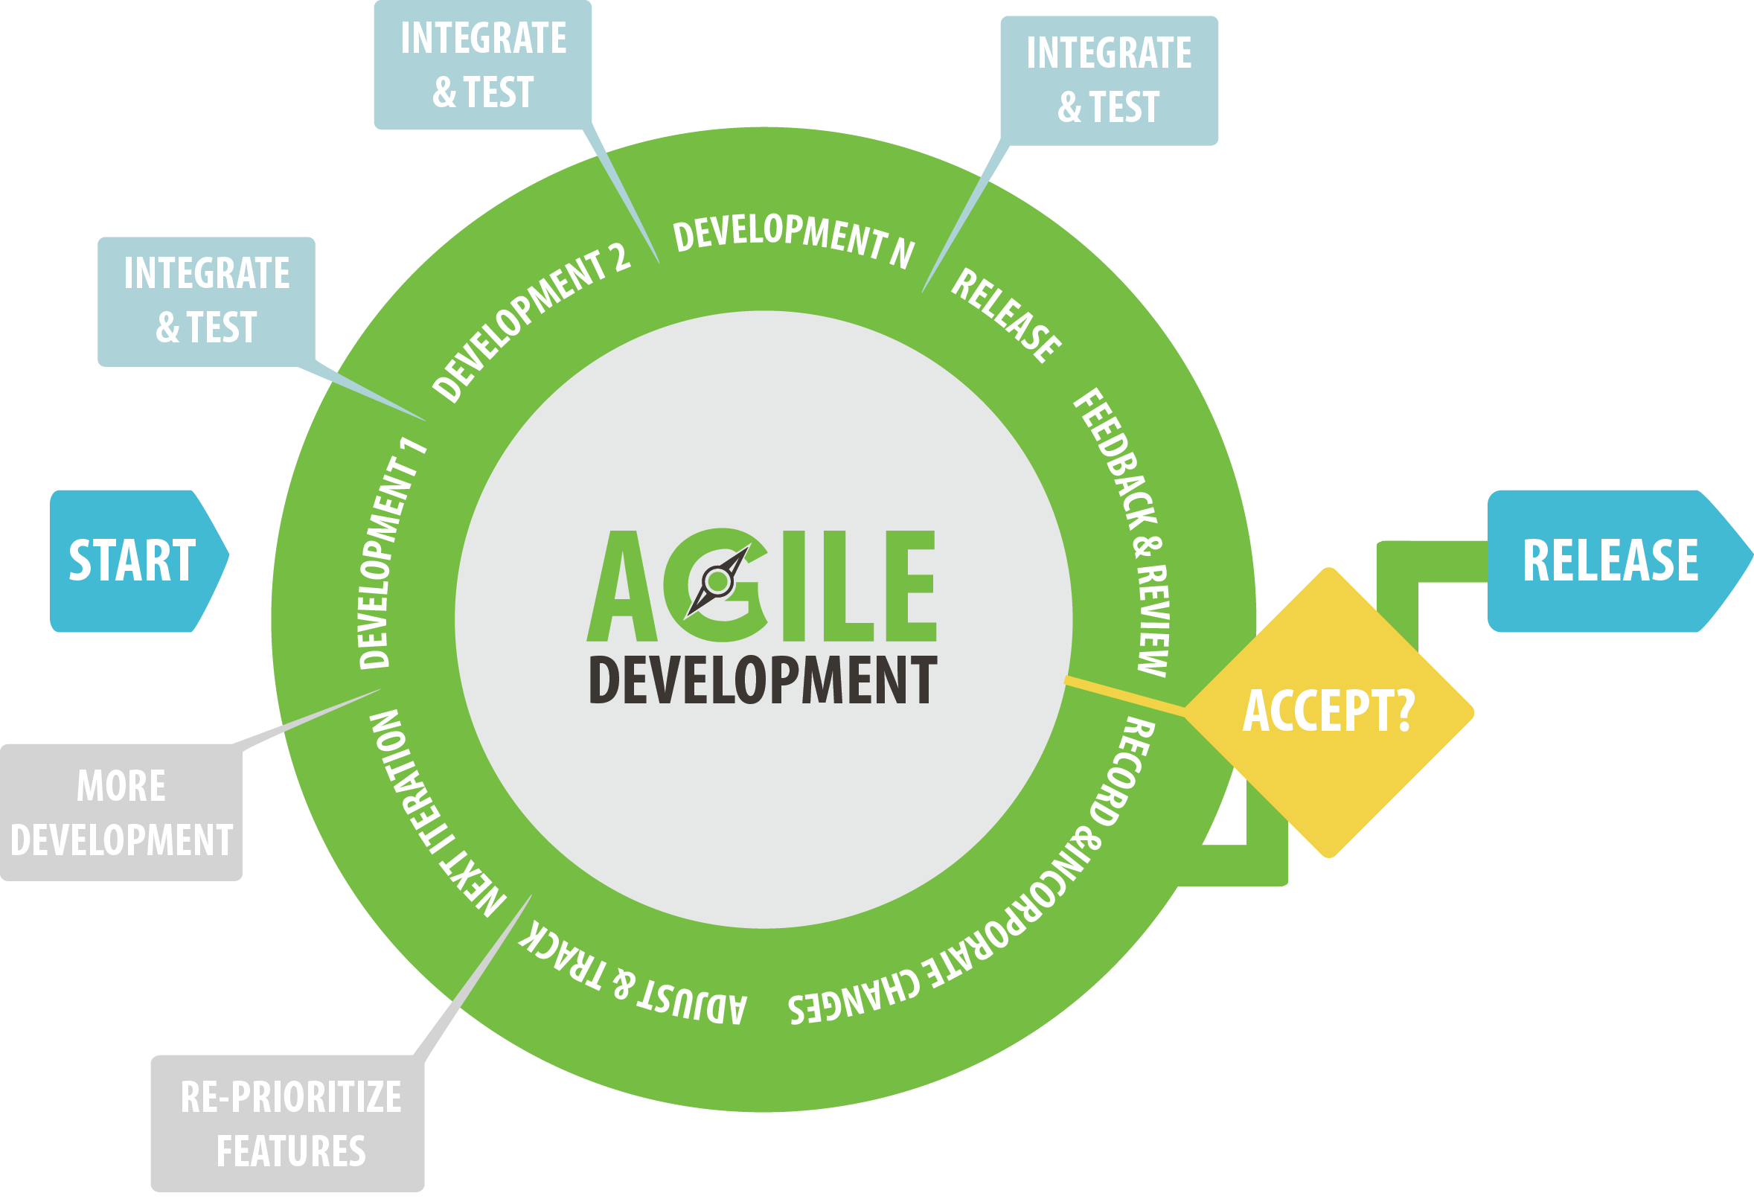

**Prepared For:**

**Rechard Philip**

**Senior Lecturer**

City University of Bangladesh

**Prepared By:**

**Sheuly Das**

**ID: 171442596**

Contents

The Agile Method Defined 3

The general principles of the Agile Method 3

History of Agile Method 4

Companies That Use Agile Method 4

Benefits of Using the Agile Method 5

Reference: 6

The Agile Method Defined

A sprint is a period of time allocated for a particular phase of a project. Sprints are considered to be complete when the time period expires. There may be disagreements among the members of the team as to whether or not the development is satisfactory; however, there will be no more work on that particular phase of the project. The remaining phases of the project will continue to develop within their respective time frames.

The general principles of the Agile Method

* Satisfy the client and continually develop software.
* Changing requirements are embraced for the client’s competitive advantage.
* Concentrate on delivering working software frequently. Delivery preference will be placed on the shortest possible time span.
* Developers and business people must work together throughout the entire project.
* Projects must be based on people who are motivated. Give them the proper environment and the support that they need. They should be trusted to get their jobs done.
* Face-to-face communication is the best way to transfer information to and from a team.
* Working software is the primary measurement of progress.
* Agile processes will promote development that is sustainable. Sponsors, developers, and users should be able to maintain an indefinite, constant pace.
* Constant attention to technical excellence and good design will enhance agility.
* Simplicity is considered to be the art of maximizing the work that is not done, and it is essential.
* Self-organized teams usually create the best designs.
* At regular intervals, the team will reflect on how to become more effective, and they will tune and adjust their behavior accordingly.

History of Agile Method

Many of the Agile ideas surfaced in the 1970s. Studies and reviews were conducted on the Agile Method that explains its emergence as a reaction against traditional approaches to project development.

In 1970, Dr. William Royce published a paper that discussed the managing and developing of large software systems. The paper outlined his specific ideas about sequential development. His presentation stated that a project could be developed much like a product on an assembly line. Each phase of the development had to be complete before the next phase could begin. The idea required that all developers must first put together all of the requirements of a project. The next step was to complete all of its architecture and designs. This is followed by writing the code. The sequences continue in complete increments. As these steps are completed, there is little or no contact between specialized groups that complete each phase of the project.

Pioneers of the Agile Method believed that if developers studied the process, they would find it to be the most logical and useful solution to software development.

Companies That Use Agile Method

Although there is no official list of companies that use the Agile Method for their projects, IBM is one of the companies that openly uses this method to develop software. Many companies will adopt the use of this method within their development structure, but they aren’t always open about their choice to use it.

According to IBM, the use of the Agile Method means that significant organizational changes will take place. They believe that many Agile software development teams will increase their chances of success by partnering with a trusted guide. They help clients implement their own Agile software development strategies for their projects. They provide critical guidance that will help Agile software development teams to avoid common adoption, expansion, and implementation pitfalls.

Benefits of Using the Agile Method

The Agile Method grew out of the experience with the real-life projects of leading software professionals from the past. Because of this, the challenges and limitations of traditional development have been discarded. Subsequently, the Agile Method has been accepted by the industry as a better solution to project development. Nearly every software developer has used the Agile Method in some form.

This method offers a light framework for assisting teams. It helps them function and maintain focus on rapid delivery. This focus assists capable organizations in reducing the overall risks associated with software development.

There are many critics of the Agile Method; however, this method produces results that clients can take to the bank. Although a project may not turn out exactly as the client envisions, it will be delivered within the time that it needs to be produced. Throughout the process, the client and the team are changing the requirements in order to produce the quality needed by the client. Clients are happy with the results, and the team satisfies the client’s needs. The ongoing change can sometimes give both the client and the team more than they had originally envisioned for the product. The Agile Method really is a winning solution for everyone involved in software development.

Reference:

1. Project 320_A Beginners Guide To Understanding The Agile Method.

<https://project320.com/resources/the-agile-method/>